

**Team: CMP669**

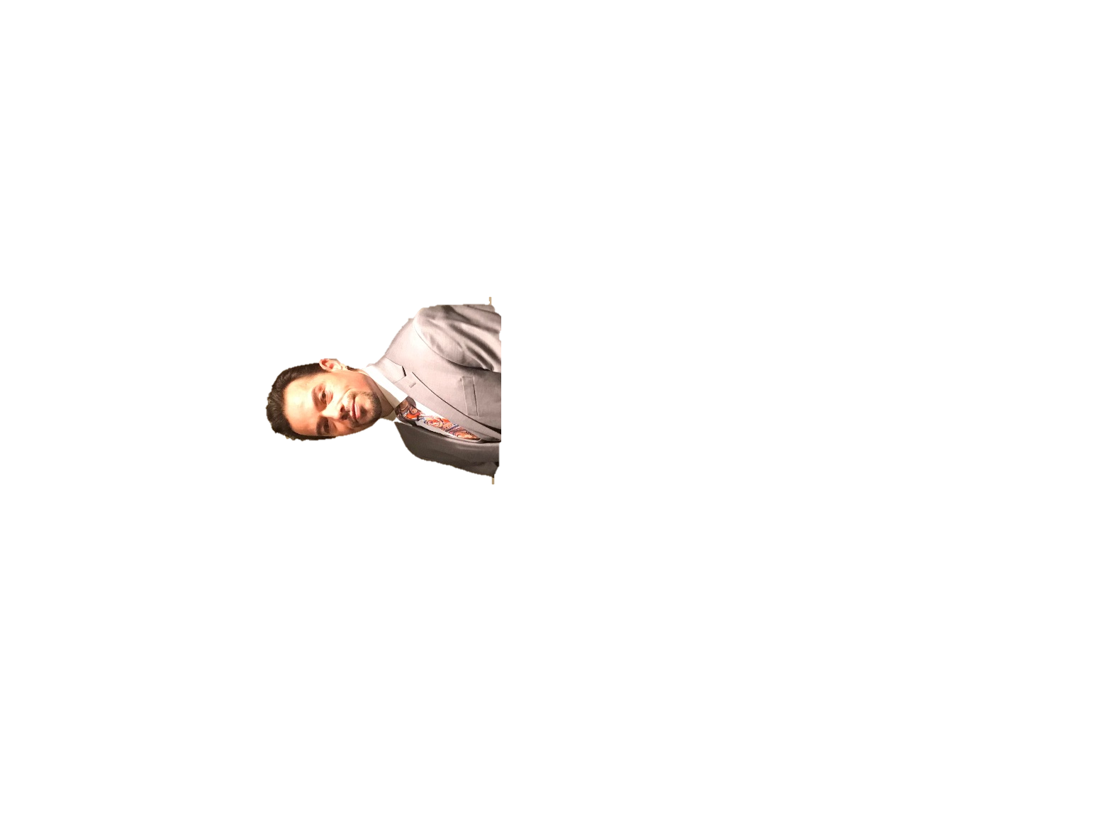

**Cengiz Han Beslen Nguyen Minh Chau**

**Wednesday, March 11, 2020**

CMP 669 Software Engineering Project

Course Project Package 1

**Virginia International University / Fairfax University of America**